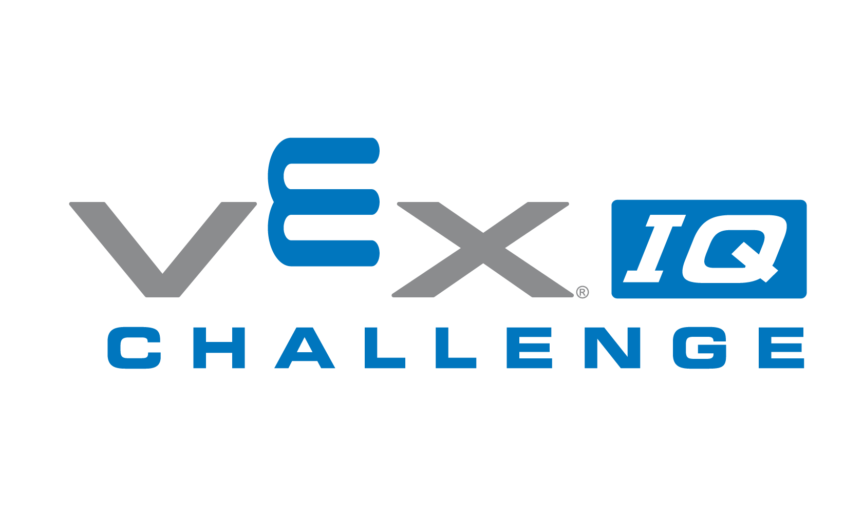

2024 U.S. Open Robotics Tournament
VEX IQ
Iowa West Field House, 5 Arena Way, Council Bluffs, IA

Monday, March 18, 2024

2:30PM-5:30PM Team Registration
3:00PM-6:30PM Inspection
3:00PM-8:00PM Practice
3:00PM-8:30:00PM Skills (Each team is allotted 3 attempts at each skills challenge. Top 3 scores at the end of skills will earn a trophy. Skills runs are only held on Monday.)
9:00PM Venue Closes

Tuesday, March 19, 2024

7:45AM Pit Opens
8:15AM-8:30AM Drivers and Coaches Meeting
8:30AM-8:55AM Opening Ceremony
8:55AM-12:30PM Qualifying Rounds
12:30PM-1:30PM Lunch
1:30PM-5:30PM Qualifying Rounds
6:00PM-7:00PM Mega Alliance
7:30PM Venue Closes
Super Mega Alliance will begin 15 minutes after the last qualification match for Elementary and Middle School and will last approximately 2 hours. Venue Closes 15 minutes after the Team Super Mega Alliance ends!

Wednesday, March 20, 2024

8:00AM Pit Opens
8:15-8:30 Q & A/Awards
8:30AM-12:00PM Qualifying Rounds
12:00PM-1:00PM Lunch
1:00-2:30PM Qualifying Rounds
3:00PM-4:10PM Finals
4:10PM-4:45PM Closing Ceremony
5:00PM Venue Closes

